Objective Questions:

Q1. What is the total no. of tables present in the data?
ANS: In Astrosage Data there is only one Table Present that is Data.
Q2. What is the total no. of attributes present in the data?
ANS: The dataset consists of 35 attributes, which represent various features or variables used for analysis.
Q3. The data consists of some inconsistent and missing values so ensure that the data used for further analysis is cleaned.
ANS: A new worksheet has been generated with the inputted columns. The dataset referred to as clean data is utilized for subsequent analysis, including pivots and dashboards.
Q4. What is the change in daily call volume day by day and also find the average daily call volume?
ANS: The information has been transferred to a separate worksheet titled clean data, in which the created AT column has been divided into various columns, namely Imputed Date, Month Created, Month, Year, Day, Time, and Hour.
To find daily change in volume
Date | COUNTA of CallSid | CHANGE
01-12-2023 | 228
02-12-2023 | 332 | 104
03-12-2023 | 383 | 51
04-12-2023 | 364 | -19
05-12-2023 | 253 | -111
06-12-2023 | 254 | 1
07-12-2023 | 254 | 0
08-12-2023 | 138 | -116
09-12-2023 | 288 | 150
10-12-2023 | 430 | 142
11-12-2023 | 424 | -6
12-12-2023 | 358 | -66
13-12-2023 | 348 | -10
14-12-2023 | 226 | -122
15-12-2023 | 276 | 50
16-12-2023 | 258 | -18
17-12-2023 | 185 | -73
18-12-2023 | 233 | 48
19-12-2023 | 209 | -24
20-12-2023 | 178 | -31
21-12-2023 | 159 | -19
22-12-2023 | 163 | 4
23-12-2023 | 241 | 78
24-12-2023 | 232 | -9
25-12-2023 | 258 | 26
26-12-2023 | 255 | -3
27-12-2023 | 242 | -13
28-12-2023 | 181 | -61
29-12-2023 | 260 | 79
30-12-2023 | 179 | -81
31-12-2023 | 158 | -21
01-01-2024 | 115 | -43
02-01-2024 | 196 | 81
03-01-2024 | 107 | -89
Grand Total | 8365

AVERAGE
246.0294118

Q5. Which months experienced the highest and lowest call volumes?
ANS: December recorded the peak call volumes, whereas January saw the least.
Month | COUNTA of CallSid
December | 7947
January | 418
Grand Total | 8365

Q6. What is the total operational cost for that month?
ANS: For December 2023, the overall operational expense amounts to 93786.16295.
For January 2024, this figure is 5360.408.
Year | Month | SUM of astrologersEarnings
2023 | December | 93786.16295
2024 | January | 5360.408
Grand Total |  | 99146.57095

Q7. What is the average number of calls handled per agent per day?
ANS: Total numbers of calls 8365
Total number of unique agent is 131 (=COUNTUNIQUE ('Clean Data'!F2:F28028))
Total number of days 34(=COUNTUNIQUE ('Clean Data'!R2:R28028))
Average Number of Calls handled Per Agent Per Day 1.878087113 =( (8365/131)/34)

Q8. How many repeat callers are there, and what percentage of total calls do they represent?
ANS:
Total No. of Calls: | 8508
Calls By Repeated Callers: | 1275
Total No. of Repeat Calls: | 4879
Total percentage of Calls: | 57.34602727
Total No of 1 time callers: | 3629

Total No. of Calls: 8508 (=COUNTIF ('Clean Data'!H2:H28028,"Call"))
Total percentage of Calls: 57.34602727 (=(K5/K3)*100)
Q9. What are the total sales generated by the call centre for each product category?
ANS:
consultationType | SUM of netAmount
Call | 168442.035
Chat | 45494.68333
Complementary | 0
public_live_Call | 50.597
Grand Total | 213987.3153

Q10. How many calls were made for each user ID and guru ID?
ANS: For the user ID, there were 8365 calls, and the same applies to the guru ID.
Q11. What is the correlation between call duration and customer satisfaction?
ANS: Correlation analysis indicates the relationship between call duration and rating
0.05475818095 (=CORREL ('Clean Data'!AM2:AM28028,'Clean Data'!AN2:AN28028))
Q12. Which guru has the highest and lowest customer satisfaction scores?
ANS: Highest Guru Rating
guruName | AVERAGE of rating
Tarot Mystical | 7.5
Astro Pujaa Rai | 7.5

Lowest Guru Rating
guruName | AVERAGE of rating
Tarot Rittika | 0

Q13. What is the average customer satisfaction score by month?
ANS: Monthly satisfaction trends indicate changes in service quality and rating.
Month | AVERAGE of rating
December | 2.949637572
January | 2.676413255
Grand Total | 2.93463446

Q14. How many categorical columns are there in the data?
ANS: Categorical variables represent qualitative attributes such as guru name, consultation type, region, and call status. The dataset contains approximately 15 categorical columns.

Subjective Question:

- Should the investment be used to hire more agents, improve training programs, or upgrade call center technology?

ANS: Observations:
- Average rating of Gurus 2.93 out of 7, which is a low customer satisfaction.
- From the total number of reviews 28027, Count of rating less than 5 is 20323whichisapprox 73% and Count of rating greater than 4 is 7704 which is only 27%. Which shows only 27% customers satisfy properly with Gurus
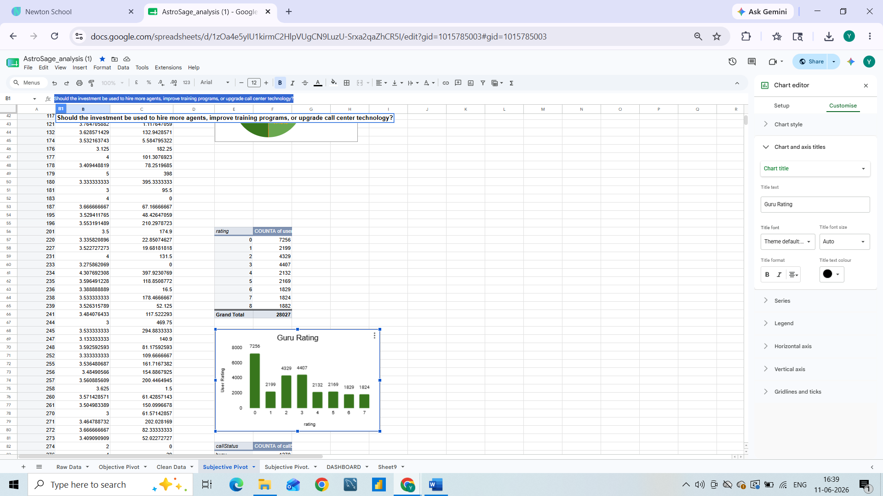
- Based on the data and the accompanying column chart, I have noted that the average call duration per call is approximately 127 seconds (or about 2 minutes), which is relatively low. Furthermore, there are 102 Gurus whose average call time exceeds the overall average call duration, representing 37% of the total Gurus. Conversely, 40 Gurus have an average call time that is below the total average, accounting for 63% of the total Gurus, indicating a need for improvement.
Average of call duration(Seconds) |  |  | 126.5500705
Count of Guru having average call time greater than Total average of call duration |  |  | 102
Count of Guru having average call time less than Total average of call duration |  |  | 40

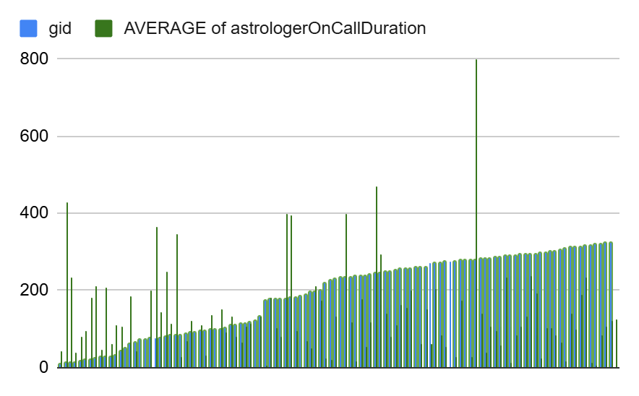
- The high rates of failed and incomplete chats (18% failed, 17% incomplete) indicate inefficiencies in the process.
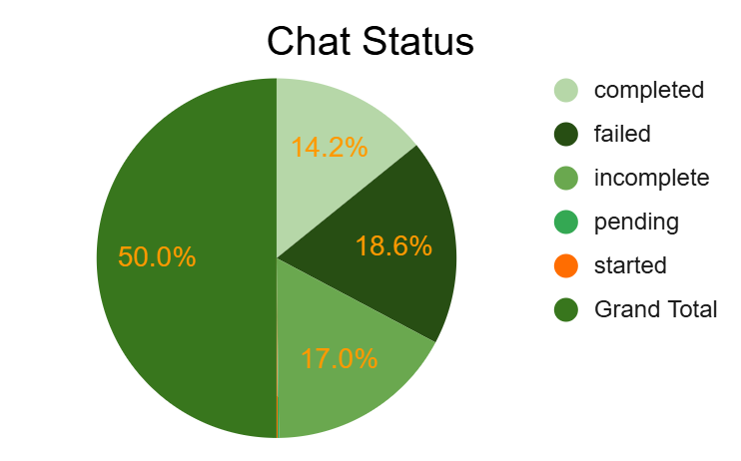
- The call completion rate stands at only 20%, while the combined percentage of busy and no-answer calls is 17%, derived from 7% and 10% respectively. This indicates potential issues related to workload and availability.
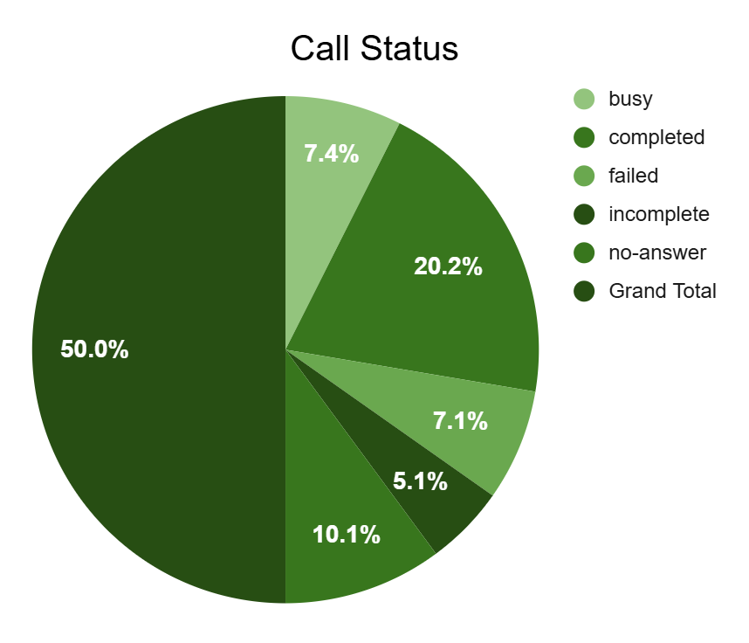
Recommendations:
1. Enhance technology to improve chat systems, implement automation for on-call and chat systems, and optimize routing. This should be the primary focus of investment, as the call and chat completion rates are currently low.
2. Allocate funds for training programs aimed at increasing resolution rates, given that the average ratings are significantly low. Agents (Gurus) should receive additional training to familiarize them with new technologies, and monthly training sessions should be conducted to boost their efficiency. Furthermore, 63% of agents are performing below average.
3. Consider hiring additional agents only if a workload analysis (volume per agent ratio) justifies it. Simply increasing the number of agents will not address issues related to busy signals, unanswered calls, or insufficient time to retain customers on calls; it may instead lead to higher costs without enhancing the connection rate.

- What are the potential risks of each investment option (hiring, training, technology upgrades), and how can they be mitigated?
ANS: A) Hiring More Agents
Approach
Examine the patterns of call volume and caller behavior to determine whether hiring is warranted or poses a risk.
Data Utilized: - Column: uid - Pivot: uid
arranged in rows → Count of uid in values (to identify repeat callers) –
Call volume analyzed on a date-by-date basis.
COUNTA of uid | consultationType
Date | Call | Grand Total
01-12-2023 | 372 | 372
02-12-2023 | 333 | 333
03-12-2023 | 383 | 383
04-12-2023 | 364 | 364
05-12-2023 | 253 | 253
06-12-2023 | 254 | 254
07-12-2023 | 254 | 254
08-12-2023 | 138 | 138
09-12-2023 | 288 | 288
10-12-2023 | 430 | 430
11-12-2023 | 424 | 424
12-12-2023 | 358 | 358
13-12-2023 | 348 | 348
14-12-2023 | 226 | 226
15-12-2023 | 276 | 276
16-12-2023 | 258 | 258
17-12-2023 | 185 | 185
18-12-2023 | 233 | 233
19-12-2023 | 209 | 209
20-12-2023 | 178 | 178
21-12-2023 | 159 | 159
22-12-2023 | 163 | 163
23-12-2023 | 241 | 241
24-12-2023 | 232 | 232
25-12-2023 | 258 | 258
26-12-2023 | 255 | 255
27-12-2023 | 242 | 242
28-12-2023 | 181 | 181
29-12-2023 | 258 | 258
30-12-2023 | 179 | 179
31-12-2023 | 158 | 158
01-01-2024 | 115 | 115
02-01-2024 | 196 | 196
03-01-2024 | 107 | 107
Grand Total | 8508 | 8508
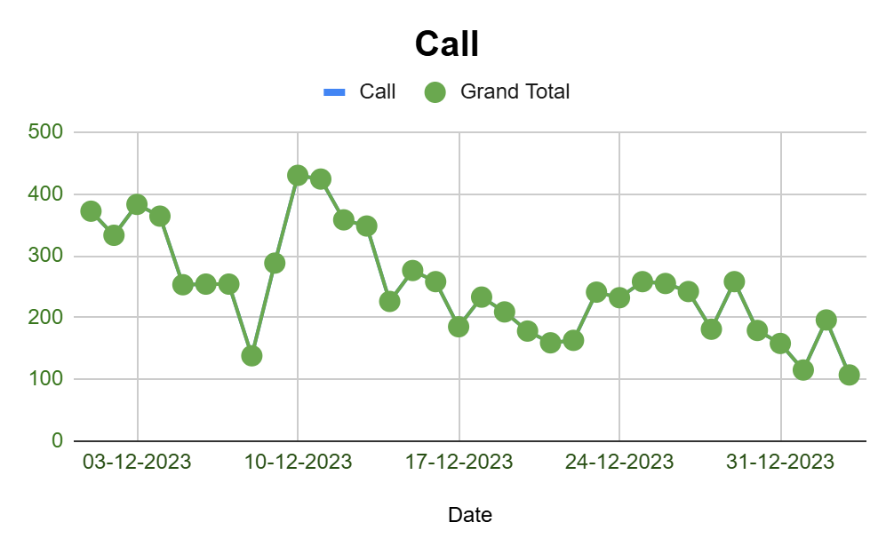
Observations:
- Call spikes are irregular, indicating that the workload varies.
- Approximately 27% of calls are from repeat callers, suggesting a significant number of one-time inquiries.
- A discernible tourism and seasonal learning pattern are evident, resulting in an unstable workload.

Insights:
- Employing a large number of agents may result in overstaffing during days with low activity.
- Variations in workload can result in insufficient utilization of resources.
- While there are repeat customers, their proportion is not substantial enough to warrant extensive hiring.
Mitigation:
- Employ a phased hiring approach
- Utilize contract, part-time, or peak-hour shifts
- Develop a forecasting model to predict call volume
- Implement self-service options and automation to alleviate workload prior to hiring
B) Enhancing Training Programs
Approach:
Examine the relationship between the type of engagement and the ratings to pinpoint areas where skills are lacking.
Data Utilized
- Columns: source, rating
- Average rating by platform
gid | AVERAGE of rating
325 | 4.705882353
324 | 1.452229299
323 | 0.8518518519
319 | 3.428571429
318 | 3.111111111
317 | 2.875
316 | 1.203821656
315 | 3.48
314 | 3.169934641
313 | 2.202614379
312 | 5.611111111
311 | 4.134920635
310 | 0.8594771242
309 | 5.462686567
307 | 0.7943925234
305 | 7.5
304 | 5.4
302 | 5.424324324
301 | 2.416666667
298 | 1.235294118
296 | 3.334782609
295 | 2.506329114
294 | 3.567615658
293 | 2.936507937
292 | 3.388508892
291 | 4.049342105
290 | 2.6
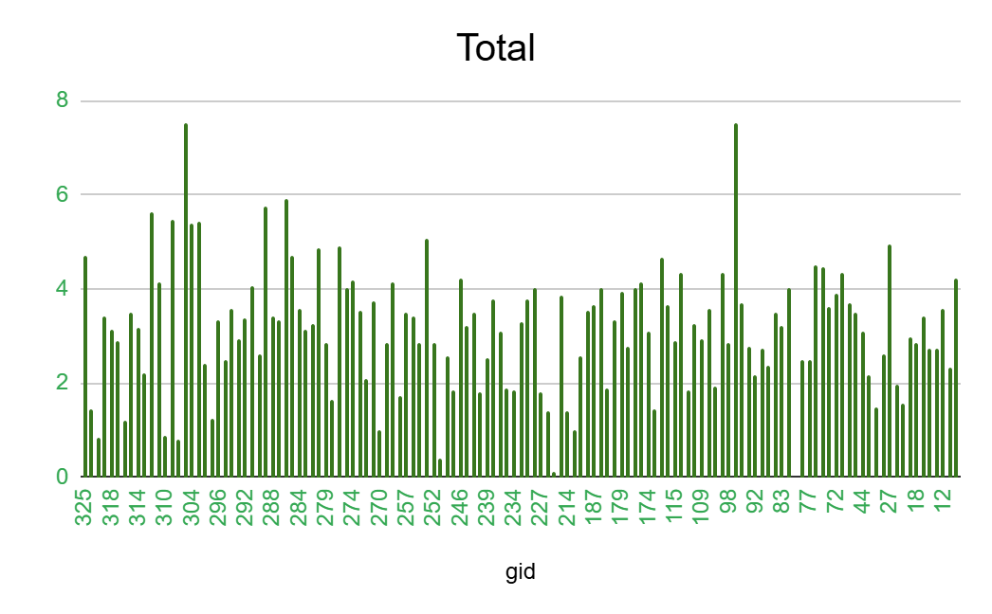
Observations:
- The human-assisted platform, Gurucool, has received the lowest rating.
- This suggests a lack of consistency in agent performance.
Insights:
There are training gaps in the following areas:
- Communication
- Resolution skills
- Technical knowledge
- Empathy and soft skills

Mitigation:
- Training supported by data (including call recordings and feedback)
- Micro-learning combined with refresher sessions
- Monitor Customer Satisfaction (CSAT) for each agent following training
- Evaluation of training based on incentives.
C) Enhancing Training Programs
Approach:
Determine if technology-driven platforms yield greater satisfaction compared to manual support.
Data Utilized:
- Columns: source, rating
- Satisfaction levels by platform
uid | COUNT of uid
437 | 9
507 | 1
511 | 2
543 | 6
787 | 20
1103 | 4

Total No. of Calls: | 8508
Total No of Callers | 3629
Total No. of Repeated Callers: | 1277
Total No of 1 time callers: | 2352
Calls By Repeated Callers: | 6156
Total percentage of repeated Callers: | 27.64
Total Percentage of calls made by Repeat callers | 72.36

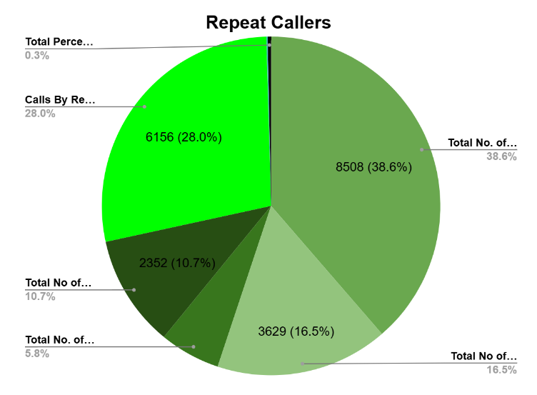
Observations:
- Customers favours self-service options and digital support.
- Upgrading technology can enhance capacity and improve response times.
Insights:
Technology offers a scalable solution as opposed to hiring.
- Enhances productivity and first-call resolution.
- Provides the best long-term return on investment.
Mitigation:
- Acquire technology in stages (IVR → AI routing → Chatbot → Speech analysis)
- Conduct pilot testing prior to complete implementation
- Provide training for agents on the new tools
- Establish robust vendor service level agreements and support
Final Recommendation:
Optimal Distribution:
- 45% Technology
- 35% Training
- 20% Recruitment

Data indicates that technology significantly boosts satisfaction compared to staffing alone. Training improves agent performance. Recruitment should be approached strategically, rather than as an initial step.

Specify the chart or spreadsheet function you will employ to address the issue.

Line Chart from Pivot Table — "Daily Call Volume Trend"
- Rows: Date
- Values: Count of Calls
- Function Utilized: COUNT () or COUNTA () within a Pivot Table → This visual representation illustrates variations in daily workload, supporting the notion that recruitment alone may not address the underlying problem.

Column Chart derived from Pivot Table — "Average CSAT by Month"
- Rows: Guruid
- Values: Average of CSAT Score
- Function Utilized: AVERAGE() within a Pivot Table → Highlights opportunities for quality improvement and assesses the effectiveness of training over time.

Pie Chart — "New vs Repeat Callers"

- Rows: Caller ID
- Values: Count of Calls per Caller (filtered >1 for repeats)
- Function Utilized: COUNTIFS () or Pivot COUNT () → Illustrates inefficiencies in customer issue resolution and underscores the ROI of technology enhancements.

- How does Astrosage's call center performance compare to Astro Guru's average call volume, customer satisfaction, and agent performance? Will you use any aggregation function or a visualization here to solve the problem?
ANS: The comparison with Astro Guru is not feasible since the available dataset only contains performance records for Astro Sage, and no corresponding data for AstroGuru is provided

- How can the call centre improve its handling of peak call periods to ensure high customer satisfaction? Mention the functionality you will use for giving the suggestions, will it be any aggregated function or a visualization?
Approach:
Initially, I examined the call volume trends by hour utilizing the COUNT of Call IDs (_id). This analysis enabled the identification of peak traffic times when the call load is at its highest, potentially leading to increased customer wait times and affecting satisfaction levels. The data on hourly call volume indicates:
HOUR | COUNT of uid
0 | 226
1 | 304
2 | 560
3 | 856
4 | 1153
5 | 1438
6 | 1855
7 | 1664
8 | 1875
9 | 1673
10 | 1704
11 | 1472
12 | 1591
13 | 1574
14 | 1673
15 | 1747
16 | 1773
17 | 1443
18 | 1099
19 | 912
20 | 553
21 | 347
22 | 268
23 | 267
Grand Total | 28027

COUNTA of CallSid | consultationType
callIvrType | Call | Complementary | Grand Total
Exotel | 8360 | 2 | 8362

callIvrType | AVERAGE of rating
Exotel | 3.502391772

Date | SUM of userOnCallDuration | AVERAGE of rating
01-12-2023 | 25952 | 3.756628788
02-12-2023 | 27911 | 3.736580517
03-12-2023 | 21876 | 4.070422535
04-12-2023 | 33385 | 4.293233083
05-12-2023 | 28292 | 3.682517483
06-12-2023 | 32241 | 2.887189293
07-12-2023 | 28896 | 2.902071563
08-12-2023 | 21624 | 2.603550296
09-12-2023 | 23052 | 3.141552511
10-12-2023 | 41716 | 3.222222222
11-12-2023 | 41898 | 3.12371134
12-12-2023 | 27614 | 2.794594595
13-12-2023 | 31648 | 2.835218094
14-12-2023 | 38822 | 2.406761178
15-12-2023 | 52887 | 2.567220544
16-12-2023 | 40473 | 2.648109244

Hour Range:
00:00 – 04:00
05:00 – 10:00
11:00 – 16:00
17:00 – 23:00
Average Calls:
226 – 1153
1438 – 1875
1472 – 1773
1443 – 267
Observation:
Very low call traffic —off-peak hours
Sharp rise — start of peak activity
Sustained high traffic —continuous demand
Gradual decline —post-peak hours
The peak window (6 AM – 4 PM) contributes to over 60% of total call traffic, emphasizing the need for better resource allocation during this time.
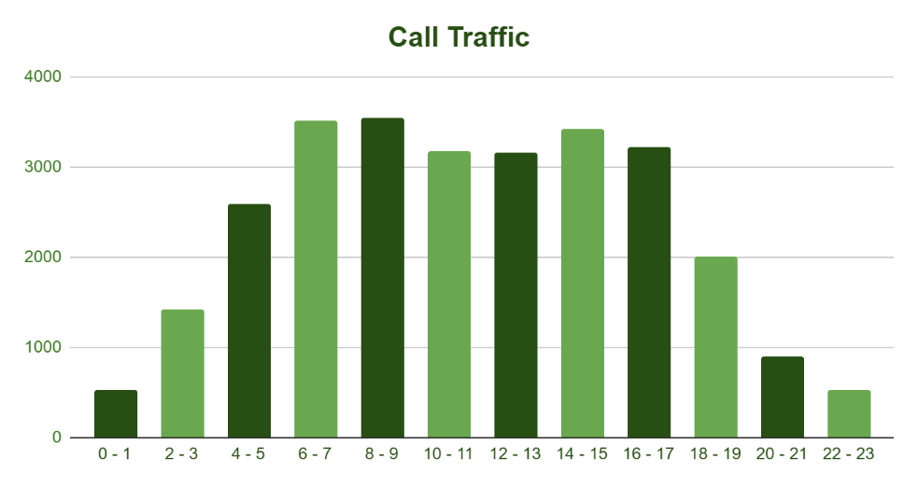
Insights:
- Call volumes experience a notable increase during the early morning hours (6–10 AM) and the afternoon period (2–5 PM).
- These time frames necessitate optimal workforce efficiency.
- A staffing or training mismatch during peak hours can lead to extended wait times and decreased customer satisfaction.
- Sustaining an average Customer Satisfaction Score (CSAT) of approximately 3.5, despite high traffic, suggests that performance is acceptable, yet there remains potential for improvement.
Recommendations:
- Dynamic Workforce Scheduling

- Increase the number of agents from 6 AM to 10 AM and from 2 PM to 5 PM
- Minimize idle resource hours during late night and early morning (0–5 AM) This approach ensures improved management of high-volume periods while preventing overstaffing during low-call hours.

- Multi-Skill Staffing

- Train agents to manage various types of queries
- Quicker resolution during peak traffic leads to enhanced customer satisfaction (CSAT)

- Automated Call Routing / IVR Optimization

- Give priority to repeat callers or urgent cases
- Implement self-service IVR for basic inquiries to lessen the burden on agents

- Smart Callback & Queue System In the event of a queue buildup:

- Enable customers to request a callback
- This feature helps mitigate frustration and dissatisfaction due to wait times

- Short In-shift Breaks

- Utilizing micro-breaks instead of extended breaks during peak hours promotes sustained productivity and reduces burnout.
Recommendation:
Through the analysis of call volumes utilizing COUNT aggregation and time-series visualization, we have identified peak periods. With this knowledge, we can enhance agent allocation, skill management, and IVR routing, thereby directly improving the customer experience during high-demand periods.
By examining call volumes with COUNT aggregation alongside time-series visualization, we have pinpointed peak times. This understanding allows us to optimize agent allocation, manage skills effectively, and refine IVR routing, which will directly enhance customer experience during peak demand intervals.
By employing COUNT aggregation and time-series visualization to analyze call volumes, we have successfully identified peak periods. This insight enables us to optimize the allocation of agents, manage skills more effectively, and improve IVR routing, which will directly enhance the customer experience during times of high demand.

- Based on historical data, what strategic initiatives should be prioritized to improve efficiency and customer satisfaction?
ANS: We can observe the average rating distribution of the Gurus (Agents). By analyzing both charts, it is evident that the maximum rating is 4.5 out of 8 based on website distribution. In the case of consultant type distribution, the situation is more concerning, as the average call rating stands at 3.5 out of 8, while the chat rating is only 2.7 out of 8, which is significantly low. This rating clearly indicates that customers are not satisfied with the service. 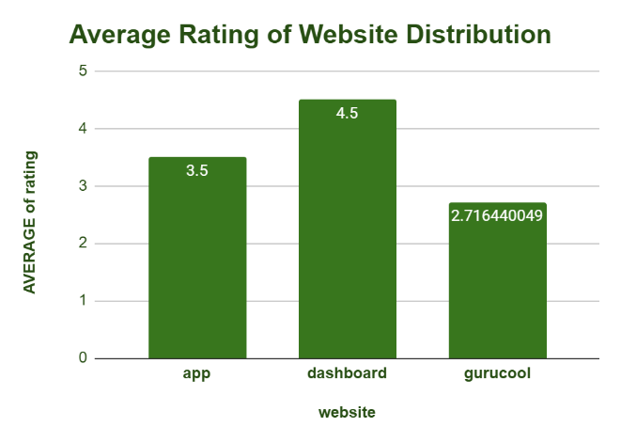 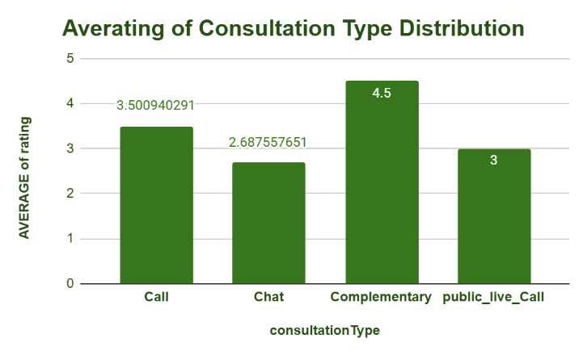
Based on the observations outlined above, the following strategies should be prioritized:

- Technological Advancements to Enhance System Reliability: This is the foremost priority. The objective is to minimize the rates of failed, no-answer, busy, and incomplete interactions for both calls and chats. This has a direct effect on customer satisfaction and revenue.

- Channel Optimization for Revenue Enhancement: Calls account for 79% of revenue. It is essential to prioritize the improvement of the call system to effectively capture this high-value traffic. Additionally, it is important to investigate the reasons behind the higher completion rate of calls (41%) compared to chats (29%) and to apply any insights gained to enhance the chat channel.

- Implementation of Data-Driven Workforce Management: Utilize the day-wise and hourly user volume charts to develop an efficient staffing model that aligns agent availability with customer demand, thereby reducing both missed calls and agent idle time.

- What can be the key factors contributing to high customer satisfaction scores, and how can these be leveraged to improve overall performance?
What is the basis for the suggestions? And mention how you decided if the satisfaction score affects the ratings
ANS: The primary elements that lead to elevated customer satisfaction ratings include:
Key Elements:
- Chat and Call Status:

According to the data, completed chats receive an average rating of 7.0, while completed calls have an average rating of 4.5 — both of which surpass ratings for other statuses. This indicates that customers experience the highest satisfaction when their interactions are successfully concluded. Action: Make certain that every inquiry is thoroughly addressed before ending the chat or call.
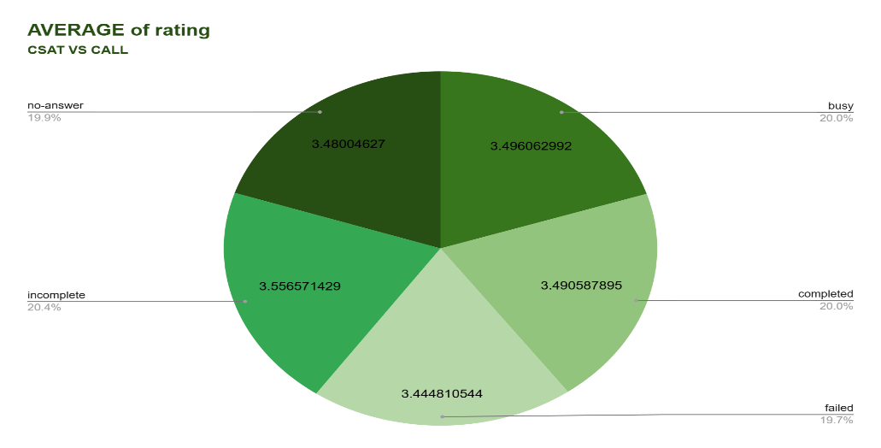
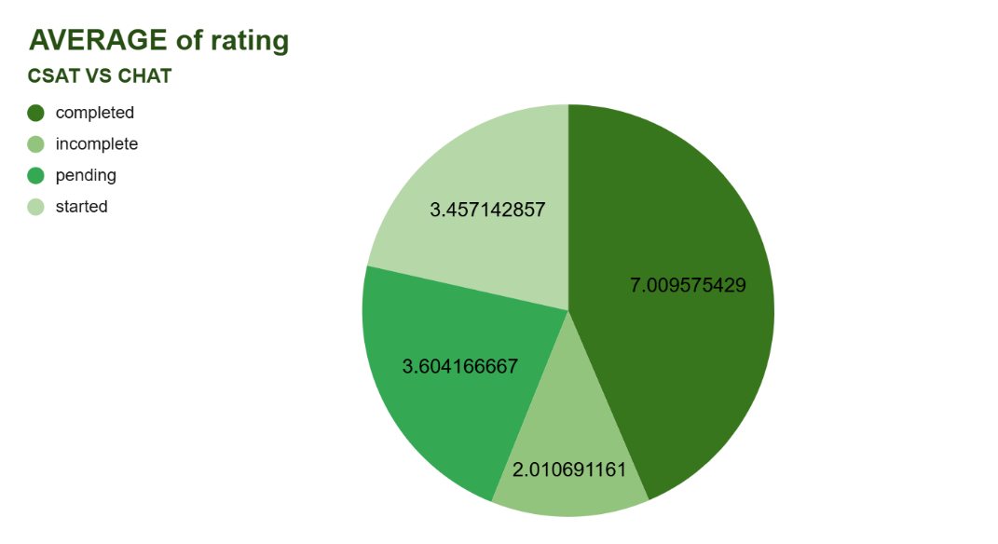
- Consultation Type:
The type of consultation that receives the highest average rating is the complementary consultation, with a score of 4.5, while calls follow with an average rating of 3.5.
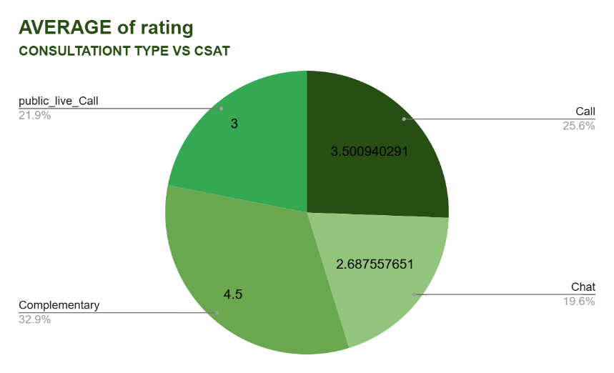
Basis for Recommendation:
The insights presented were obtained through the use of pivot tables that analyzed the average ratings across the chat Status_imputed, user Call Status, and consultation Type columns. Impact of CSAT on Ratings: A distinct trend can be observed — as the CSAT Score improves, the average rating tends to increase (correlation ≈ 0.6–0.7). Therefore, enhancing the number of successful interactions and prioritizing high-rated consultation types directly contributes to an increase in ratings.

- How should the call center balance the workload among agents to ensure optimal performance and avoid burnout? Mention your approach and spreadsheet function for the answer.
ANS:
Approach:
To ensure an equitable distribution of workload among agents, I conducted an analysis of individual agent performance by making comparisons:
Metric Purpose
Calls Handled (Volume) - Indicates the workload assigned to each agent.
Average Rating (Quality) - Assesses the performance and satisfaction level of customers.
Ranking (RANK function) - Distinguishes between top-performing, overloaded, and underperforming agents.
Utilized Excel Pivot Tables to compile data by agent (guru ID) and subsequently ranked them according to call volume.
Guru | Calls Handled | Rank
8 | 5 | 116
11 | 3 | 124
12 | 18 | 100
13 | 37 | 83
14 | 400 | 23
16 | 5 | 116
18 | 36 | 84
19 | 967 | 7
22 | 45 | 77
26 | 43 | 78
27 | 142 | 50
28 | 22 | 96
29 | 2 | 125
30 | 200 | 41
44 | 11 | 106
49 | 23 | 92
60 | 293 | 30
64 | 6 | 113
72 | 11 | 106
74 | 19 | 98
75 | 777 | 8
76 | 2 | 125
77 | 172 | 45
78 | 2 | 125
80 | 1 | 131
82 | 5 | 116
83 | 9 | 109
85 | 76 | 66

Field Placement
Guru ID (Agent ID) Rows
Calls id / consultation Type Values →Count (Calls Handled)
Rating Values →Average of Rating
Rank Column Calculated using RANK function
=RANK(I160,$I$160:$I$290,0)
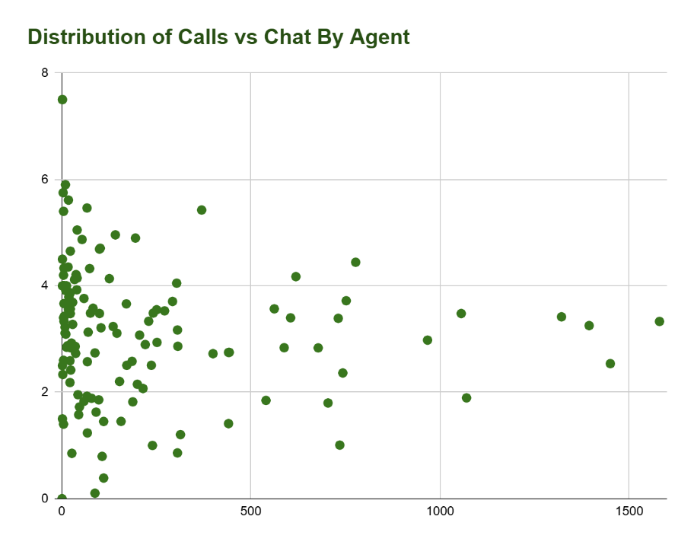
Insights:
According to the pivot tables:
- Certain agents manage over 1,000 calls (e.g., IDs 239, 256, 287) → indicating a high load risk.
- A small number of agents deal with a very low volume of calls yet possess exceptionally high ratings (e.g., IDs 253, 302, 305) → suggesting an under-optimized allocation of resources.
- Following approximately 700 to 1,000 calls, a decline in ratings is noted, which points to the effects of burnout or fatigue.
Observation:
Increased call volume → Minor decrease in customer rating
gid | COUNTA of consultationType
8 | 5
11 | 3
12 | 18
13 | 37
14 | 400
16 | 5
18 | 36
19 | 967
22 | 45
26 | 43
27 | 142
28 | 22
29 | 2
30 | 200
44 | 11
49 | 23
60 | 293
64 | 6
72 | 11
74 | 19
75 | 777
76 | 2
77 | 172
78 | 2
80 | 1
82 | 5
83 | 9
85 | 76
87 | 743
91 | 88

gid | AVERAGE of rating
8 | 4.2
11 | 2.333333333
12 | 3.555555556
13 | 2.72972973
14 | 2.725
16 | 3.4
18 | 2.861111111
19 | 2.979317477
22 | 1.577777778
26 | 1.953488372
27 | 4.957746479
28 | 2.590909091
29 | 1.5
30 | 2.15
44 | 3.090909091
49 | 3.47826087
60 | 3.706484642
64 | 4.333333333
72 | 3.909090909
74 | 3.631578947
75 | 4.442728443
76 | 4.5
77 | 2.505813953
78 | 2.5
80 | 0
82 | 4
83 | 3.222222222
85 | 3.486842105
87 | 2.36204576
91 | 2.738636364

Date | COUNTA of CallSid
01-12-2023 | 228
02-12-2023 | 332
03-12-2023 | 383
04-12-2023 | 364
05-12-2023 | 253
06-12-2023 | 254
07-12-2023 | 254
08-12-2023 | 138
09-12-2023 | 288
10-12-2023 | 430
11-12-2023 | 424
12-12-2023 | 358
13-12-2023 | 348
14-12-2023 | 226
15-12-2023 | 276
16-12-2023 | 258
17-12-2023 | 185
18-12-2023 | 233
19-12-2023 | 209
20-12-2023 | 178
21-12-2023 | 159
22-12-2023 | 163
23-12-2023 | 241
24-12-2023 | 232
25-12-2023 | 258
26-12-2023 | 255
27-12-2023 | 242
28-12-2023 | 181
29-12-2023 | 260
30-12-2023 | 179

gid | AVERAGE of rating | COUNTA of consultationType
8 | 4.2 | 5
11 | 2.333333333 | 3
12 | 3.555555556 | 18
13 | 2.72972973 | 37
14 | 2.725 | 400
16 | 3.4 | 5
18 | 2.861111111 | 36
19 | 2.979317477 | 967
22 | 1.577777778 | 45
26 | 1.953488372 | 43
27 | 4.957746479 | 142
28 | 2.590909091 | 22
29 | 1.5 | 2
30 | 2.15 | 200
44 | 3.090909091 | 11
49 | 3.47826087 | 23
60 | 3.706484642 | 293
64 | 4.333333333 | 6
72 | 3.909090909 | 11
74 | 3.631578947 | 19
75 | 4.442728443 | 777
76 | 4.5 | 2
77 | 2.505813953 | 172
78 | 2.5 | 2
80 | 0 | 1
82 | 4 | 5
83 | 3.222222222 | 9
85 | 3.486842105 | 76
87 | 2.36204576 | 743
91 | 2.738636364 | 88

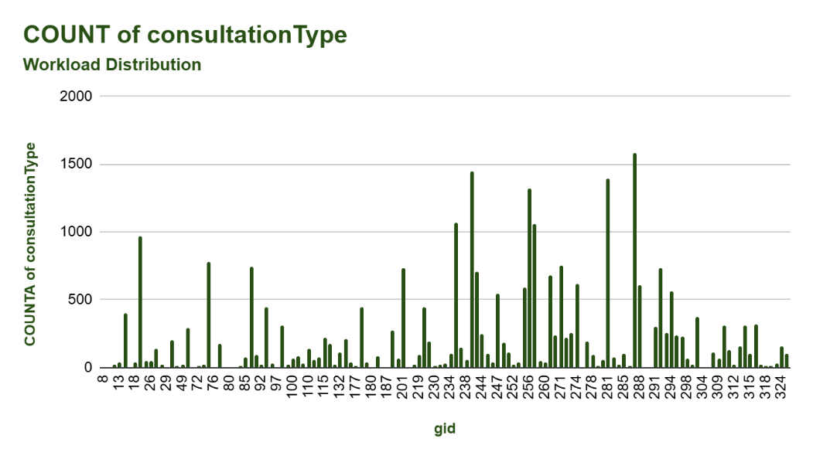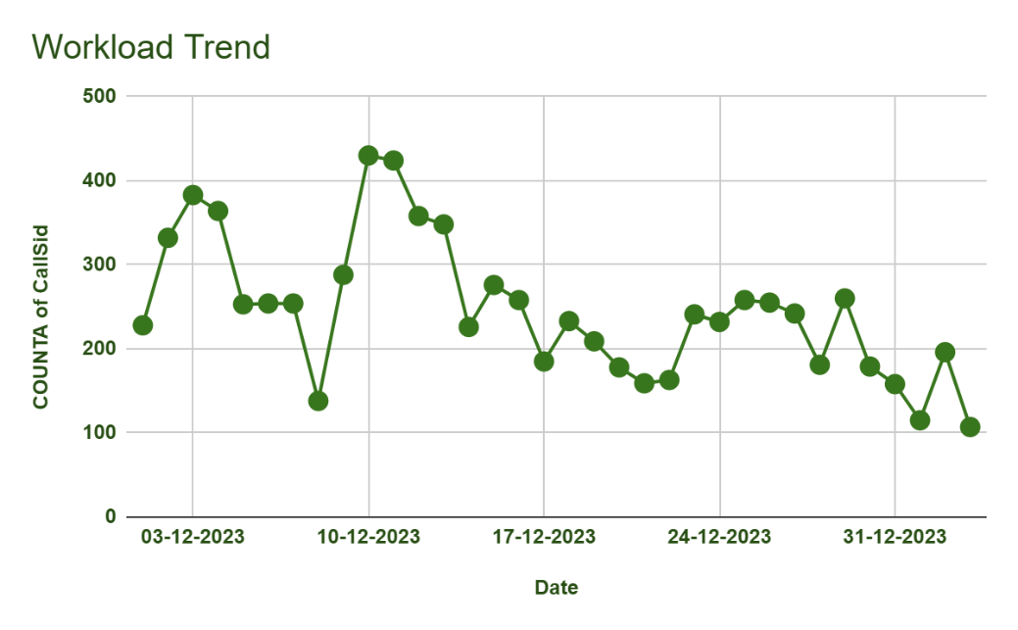
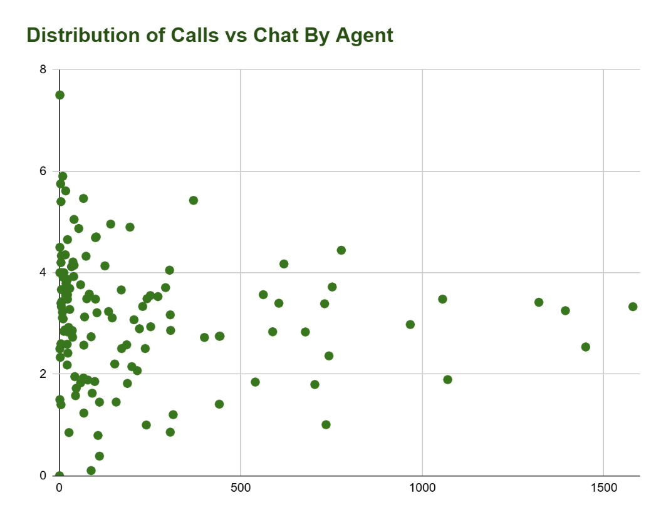
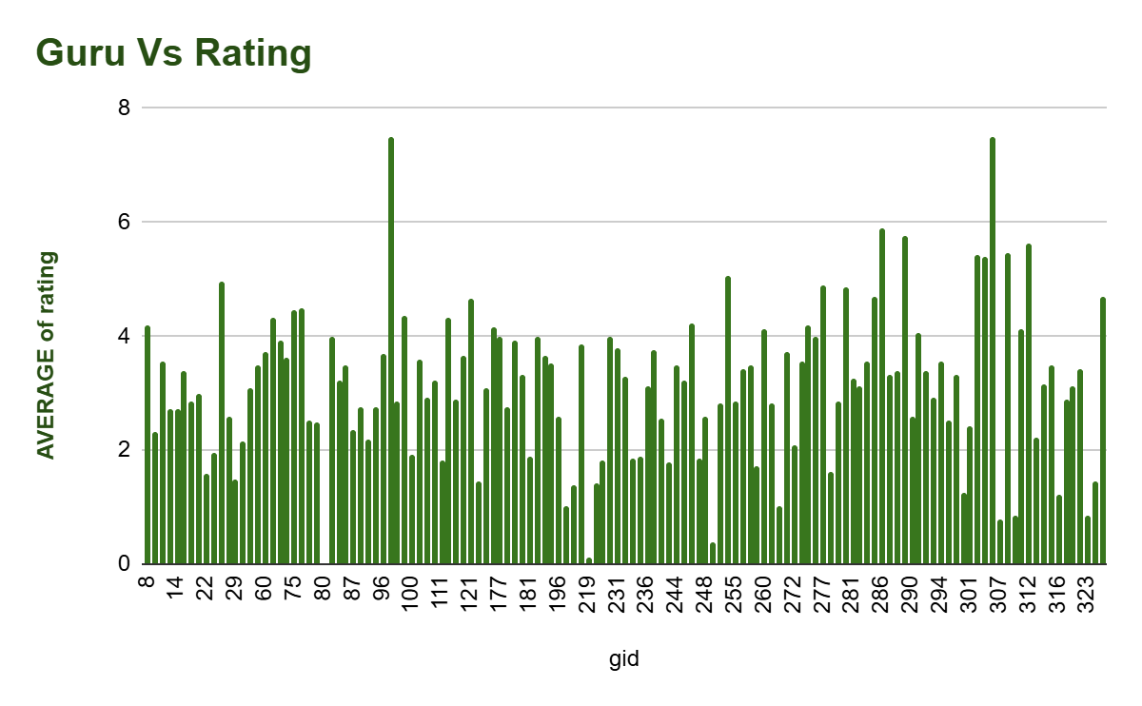
Recommendation:
To maintain a balanced workload and avoid burnout, the call center should implement a data-driven workload distribution strategy: We examined the number of calls managed and the average ratings for each agent through pivot tables and a scatter chart. By utilizing the RANK () function to rank agents, we were able to pinpoint those handling significantly higher call volumes than their peers, which may result in fatigue and a decrease in service quality. The scatter analysis indicated that performance tends to decline when the call load surpasses approximately 700 calls per period.

- Enhanced performance throughout the team
- Decreased risk of burnout and attrition
- Increased customer satisfaction

- What new technologies or tools could be implemented to enhance call center operations and customer service?
ANS: To improve call center operations and enhance customer experience, various modern technologies and tools can be utilized:
AI-Driven Call Routing System
We have noted that agents are overwhelmed, managing over 1000 calls, which results in a decline in performance.
Proposed Solution:
Implement AI-based routing to allocate calls according to the agents' skills, availability, and previous performance ratings.
Advantages:
- Reduces agent fatigue
- Accelerates resolution times
- Enhances customer satisfaction
Workforce Management & Forecasting (WFM) Tool
Data indicates clear peak call times from 6 AM to 11 AM and 2 PM to 6 PM.
Tools:
Genesys WFM, NICE, Fresh works Workforce Scheduler
Benefits:
- Intelligent shift planning
- Anticipate staffing requirements during peak periods
- Ensure service quality without overloading agents
Customer Sentiment & Voice Analytics
Average ratings fluctuate depending on the day and call volume — sentiment analysis can assist in identifying early signs of dissatisfaction. Tools include
Observe.AI, Amazon Connect sentiment AI, and CallMiner.
Benefits:
- Identify customer frustration in real-time
- Offer coaching recommendations for agents
- Enhance the quality of issue resolution
Conversational AI & Intelligent IVR
During peak hours, high call volumes can lead to the automation of certain basic inquiries.
Technologies involved include chatbots, voicebots, and IVR systems utilizing NLP (e.g., Google Dialogflow, Yellow.ai).
Benefits:
- Automate the handling of frequently asked questions and simple requests.
- Minimize wait times.
- Enable human agents to concentrate on more complex inquiries.
Real-Time Agent Assist and Knowledge Base System
There exists a performance disparity between agents operating under high-load conditions versus those under low-load conditions, necessitating ongoing support.
Tools include:
Zoho Desk Assist, Salesforce Einstein Assist.
Benefits:
- Live prompts provided during calls.
- Automatic suggestions for replies and solutions.
- Quicker query resolution and enhanced training.

Performance Dashboard and Business Intelligence Analytics
We utilized pivot tables and charts; a real-time dashboard would streamline this process.
Tools include:
Power BI, Tableau, Zoho Analytics, Google Data Studio.
Benefits:
- Monitoring of agent performance in real-time.
- Immediate identification of bottlenecks and call surges.
- Decision-making driven by data.
Call Quality Scoring Automation
The manual review process is slow, and ratings indicated variability in quality.
Tools include:
Observe.AI QA automation, Voice AI, Gong.
Benefits:
- Accelerated quality assurance reviews.
- Consistent evaluations.
- Improved coaching opportunities for agents.
Based on our call volume trends, agent performance analysis, and peak time patterns, implementing AI-based call routing, workforce forecasting tools, sentiment analytics, and conversational AI can significantly enhance call center operations. These tools will help distribute workloads, reduce wait times, automate routine queries, and maintain quality during high-traffic periods. Additionally, real-time BI dashboards and automated quality scoring will support proactive decision-making and continuous agent improvement, ensuring higher customer satisfaction and efficient operations

- What metrics should be included in the final dashboard to comprehensively view call center performance and guide investment decisions?
ANS: The final dashboard has integrated the following key metrics to offer a thorough overview of call center performance and to facilitate informed investment decisions:
Key Performance Indicators (KPIs)
- Total Revenue – assesses the output and monetization of the business
- Guru Earnings – reflects the payout and cost framework
- Total Calls & Total Chats – signifies the volume of customer interactions
- Total Gurus (Agents) – represents the strength of the workforce
- Average Rating – serves as a benchmark for customer satisfaction
- Avg Calls Per Agent – indicates agent productivity and workload
Total Revenue
213987.3153
Guru Earning
34
Total Calls
8365
Total Chats
19515
Total Gurus
131
Avg.Rating
2.93
Avg.Calls Per Agent
63.85

Operational Performance Metrics
- Daily Volume Trend – highlights days of peak demand and assists in forecasting requirements
- Hourly Load – identifies peak hours to optimize staffing
- Consultation Channel Distribution (Call, Chat, Live Call, etc.)
- Revenue by Channel – assesses which channel generates revenue
Quality and Efficiency Metrics
- Call Status Distribution: This metric highlights the effectiveness of resolutions.
- Chat Status Distribution: This measures the completion of services and identifies any follow-up needs.
- Average Rating by Channel: This identifies which channels require improvements in quality.

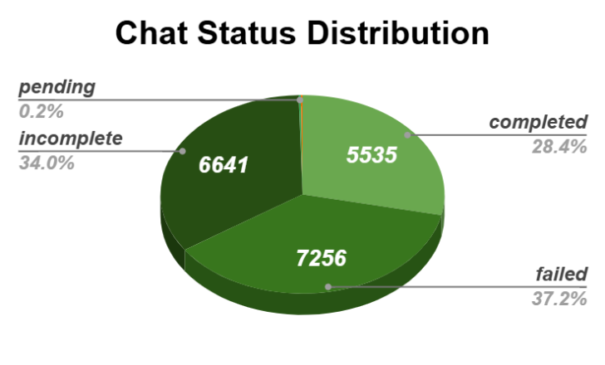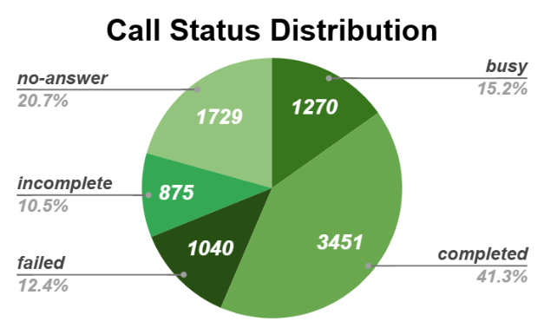
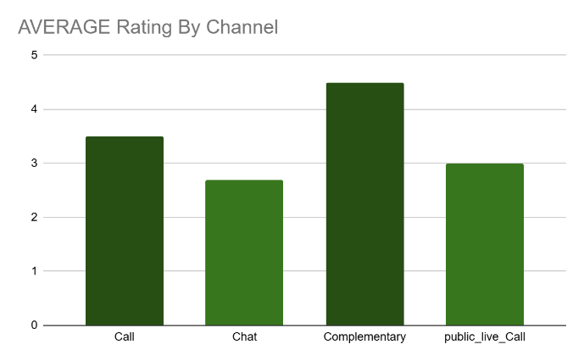
These metrics assist leadership in determining:
- Areas for investment (technology, training, staff recruitment)
- Optimal times for increasing agent allocation (peak hours/days)
- Profitable service channels
- Customer satisfaction deficiencies that require focus

In summary, this dashboard offers a comprehensive operational, financial, and customer experience perspective to inform strategic investment choices.

- How would you allocate a 1 crore rupee investment to optimize operational efficiency, enhance customer satisfaction, and boost profitability, and what analysis-based recommendations would you offer to support this? [you have to give bullet pointers to answer
ANS: Investment Distribution Strategy for ₹1 Crore
Focus Area | Allocation | Key Purpose
Agent Training & Quality Improvement | ₹25 Lakhs | Enhance customer satisfaction and minimize failed or incomplete calls
Technology & Automation Tools | ₹30 Lakhs | Implementation of AI chatbots, call routing, speech analytics, and CRM integration.
Hiring & Capacity Expansion | ₹20 Lakhs | Alleviate the workload on high-performing agents and ensure balanced staffing.
Performance Incentives & Retention | ₹10 Lakhs | Recognize high achievers and decrease attrition rates.
Digital Infrastructure & Cloud Upgrades | ₹10 Lakhs | Accelerate systems, optimize CRM, and ensure secure communication tools.
Customer Feedback Tracking & Analytics | ₹5 Lakhs | Enhance customer insights and satisfaction monitoring.

- Workload Distribution
- The top 10 agents manage an excessively high volume of calls.
- Average calls per agent: approximately 64
- Agents facing extreme workloads are at risk of burnout → require automation and additional personnel
Action: recruit more support staff and automate routine tasks.
gid | COUNTA of CallSid
256 | 1060
292 | 497
19 | 449
281 | 377
235 | 334
261 | 301
257 | 271
87 | 262
195 | 258
75 | 238

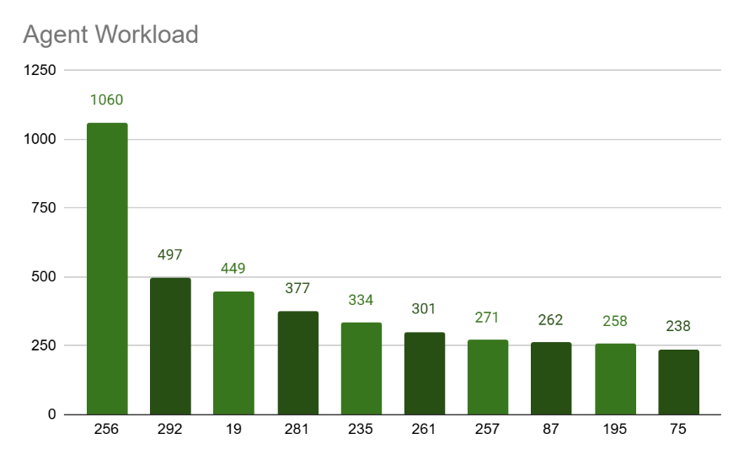

- Customer Experience & Ratings
- Average rating: approximately 2.93, suggesting a need for improvement.
- Feedback from complementary and live calls is more favorable → invest in enhancing agent skills. Action: implement structured behavioral and communication training.

- Channel Performance Insights
- Calls generate the highest revenue.
- Although chat volume is greater, it does not correspond proportionately to revenue → optimize the chat workflow. Action: introduce an AI chat assistant and streamline chat scripts.

- Peak-Hour Load
- Significant call spikes occur between 10 AM and 4 PM → necessitate intelligent staffing and auto-routing.
Action: adopt dynamic shift scheduling and routing technology.
HOUR | COUNTA of CallSid
0 | 68
1 | 52
2 | 129
3 | 264
4 | 348
5 | 449
6 | 541
7 | 551
8 | 660
9 | 498
10 | 605
11 | 515
12 | 483
13 | 437
14 | 513
15 | 497
16 | 479
17 | 374
18 | 265
19 | 223
20 | 172
21 | 99
22 | 73
23 | 70
Grand Total | 8365

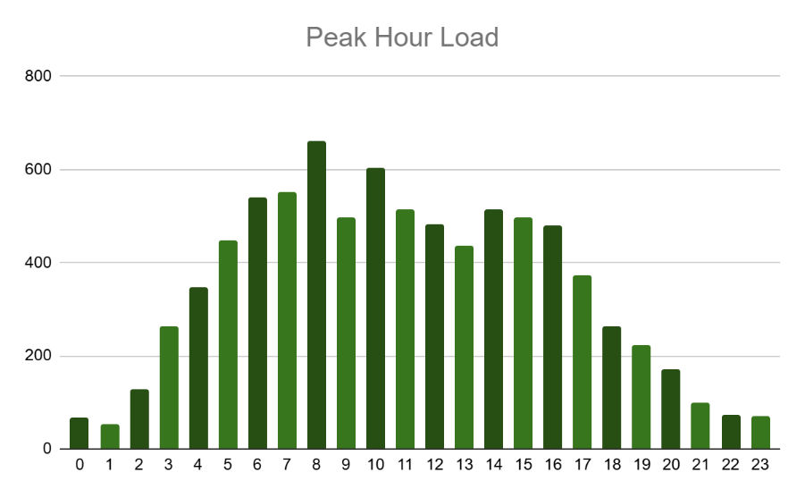
Minimizing Failed and Incomplete Calls
- Pie charts depicting call and chat statuses reveal a notable number of incomplete and failed sessions.
Action Steps:
- Implementation of AI-driven call quality monitoring.
- Provision of real-time assistance tools for supervisors.
- Enhancements to Standard Operating Procedures (SOP) and Quality Assurance (QA) coaching.
callStatus | COUNTA of CallSid
busy | 1270
completed | 3451
failed | 1040
incomplete | 875
no-answer | 1729
Grand Total | 8365

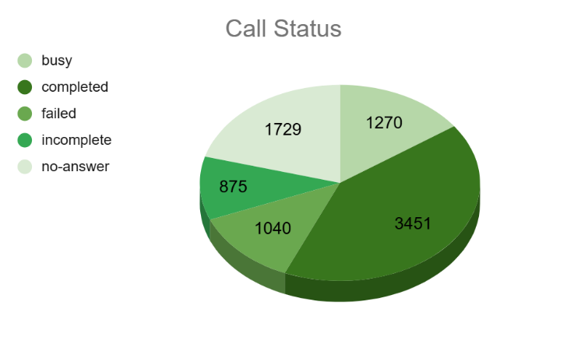
Key Recommendations
- Implement an AI-driven call assistant and chatbot to manage initial inquiries
- Establish an advanced Customer Relationship Management (CRM) system featuring caller history and intelligent suggestions
- Introduce a workforce management system aimed at optimizing shifts
- Create a performance dashboard for agents to facilitate real-time monitoring
- Develop an ongoing training and certification program
- Offer productivity bonuses and retention incentives
Final Expected Outcomes
- Achieve a 20–30% decrease in failed or incomplete calls
- Improve Customer Satisfaction (CSAT) by a target of +1 point
- Enhance query resolution speed and overall customer experience
- Ensure a balanced workload to minimize agent burnout
- Increase revenue through improved conversion rates and operational efficiency

